The 3 Best Countertop Materials for Traditional Kitchens
December 26, 2018 by The Kitchen Store
Traditional kitchens have aesthetics that are timeless and elegant. Apart from the kitchen cabinets and range, the countertops help establish the overall look of the space. They are, after all, one of the first structures you see when entering the kitchen.
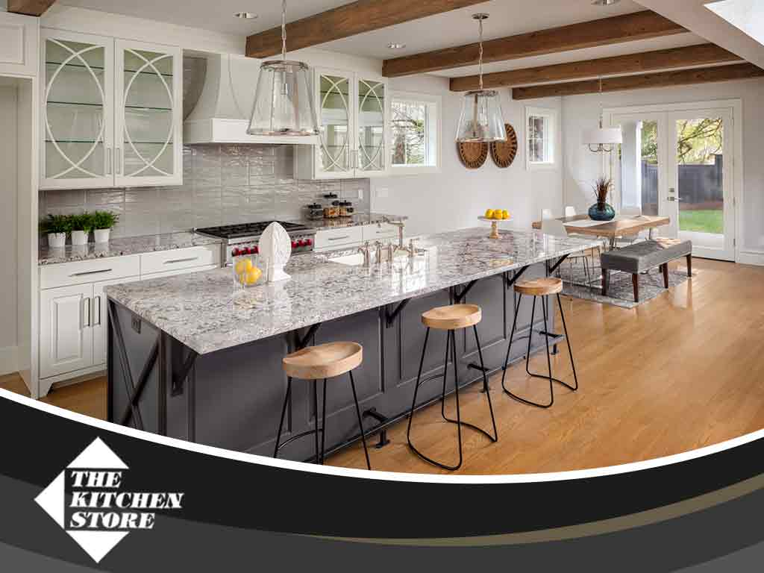
There are many materials for countertops to choose from, but three stand out as the best choices for classic kitchens. The Kitchen Store, one of the top kitchen remodeling designers in Culver City, discusses more.
Granite Countertops
As the quintessential countertop material, it’s no surprise that granite finds its way in most kitchens. It has a timeless elegance and aesthetics that are prominent and eye-catching. It’s also one of the sturdiest countertop materials available and its sheer strength makes it virtually immune to scratches and dents.
Quartz is a good alternative to granite and is a common countertop material for the traditional kitchen design. While it doesn’t have the same sheer durability as granite, it’s still a naturally occurring material, meaning they are still sturdier than the artificial countertop materials.
Marble
While most homeowners consider marble as a budget-friendly version of granite, it’s a mistake to think of them as a downgrade. In fact, it’s actually a better countertop in terms of aesthetics as it has a wider color palette and more pattern options to choose from. The waterjet design is the most popular pattern for marble countertops and fits well with traditional kitchens.
Laminate Countertops
While they can’t match granite or quartz in terms of sheer strength, laminate is still a robust countertop material. It also has the widest range of colors and patterns to choose from, which is why many homeowners prefer them over others. You can even find one that has a faux-wood pattern complete with stains – a perfect look for a classic kitchen.
At The Kitchen Store, we’ll help you find the perfect countertop material for your home’s traditional kitchen design. We also offer refacing services for traditional cabinet designs. Call us today at (310) 736-1077 to learn more about our services. We are one of the top kitchen remodeling designers in Culver City, CA.
FacebookTwitterPinterestGoogle+LinkedIn

5 Ways You Can Give Your Outdated Cabinets a Fresh New Look
December 19, 2018 by The Kitchen Store
The main role of your kitchen cabinets is to store your cooking essentials, but these structures are decorative set pieces in the kitchen as well. They help round off the look of the layout and serve as the focal point of the entire kitchen.
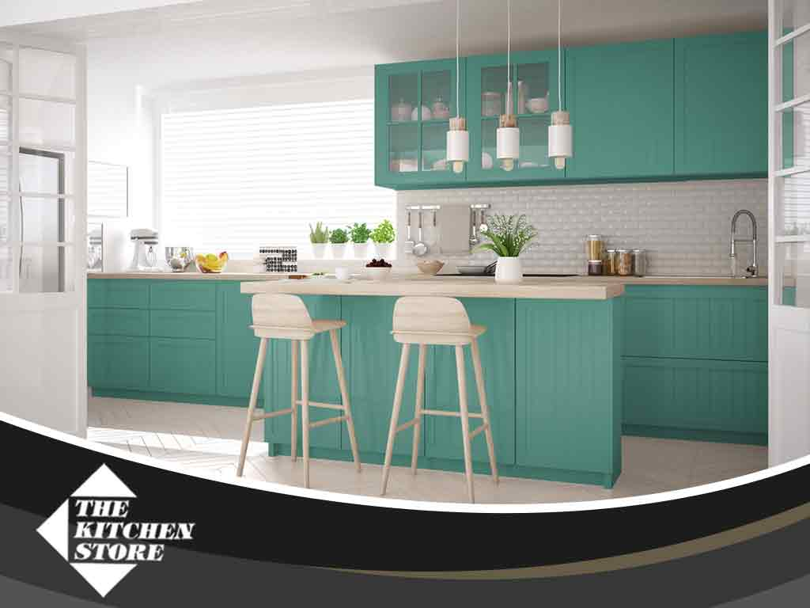
With the changing kitchen trends, it’s easy for cabinets to become outdated quite fast. Fortunately, there are many ways you can give them a fresh new look to stay on trend. The Kitchen Store, your local cabinet refacing expert, shares five ways to go about it.
1. A Fresh Coat of Paint
In many cases, it’s only the kitchen cabinets that look out of date. Instead of replacing them, simply give them a fresh coat of paint. Neutral and cool colors are always trendy, and these include tones and hues such as muted blue and light cyan.
2. Install Task Lighting
Alternatively, you can give the old cabinets some new functionality and utility by installing task lighting or uplighting. Not only do they add extra lighting that make cooking and prepping easier, but the lighting fixtures also serve as mood lighting that puts emphasis on the cabinets and transforms them into the true focal points of the kitchen. Take advantage of our custom kitchen remodeling and we’ll help you pick the best task or uplighting for your kitchen cabinets.
3. Add Glass Inserts
This is another simple way to give your cabinets a fresh new look without having to paint them. While it does take longer, the effect is striking and the glass can actually help increase the visual space of the kitchen. You have several glass options to choose from including crackled, colored, patterned and traditional clear glass.
4. Install a Roll-Out Shelf
Add some functionality to your old kitchens by installing a roll-out shelf. Not only does this make storage tidier, grabbing your kitchen essentials will be easier to do, too.
5. Add Some Molding
This pairs well with a fresh coat of paint and turns the kitchen cabinets into interesting set pieces. While there’s a wide selection of crown molding to choose from, your choice should match the architectural style of the kitchen.
At The Kitchen Store, we’ll help you give your old and outdated kitchen cabinets a fresh new look. We also offer custom kitchen cabinets made to fit your kitchen space. Call us today at (310) 736-1077 to learn more about our services. We are your local cabinet refacing expert in Beverly Hills, CA, and other parts of California.
FacebookTwitterPinterestGoogle+LinkedIn

